**LAB # 8**



**CSE-203L Circuit & Systems-II Lab**

**Fall 2022**

**Submitted by: Ali Asghar**

**Registration No.: 21PWCSE2059**

**Class Section: C**

“On my honor, as student of University of Engineering and Technology, I have neither given nor received unauthorized assistance on this academic work.”

Student Signature: ______________

Submitted to:

**Engr. Faiz Ullah**

13th December, 2022

Department of Computer Systems Engineering

University of Engineering and Technology, Peshawar

**TITLE:**

**Operational Amplifiers Applications**

**Inverting Summing Amplifier and Difference Amplifier**

**OBJECTIVES:**

* To learn how to use the operational amplifier for performing different mathematical operations like addition, subtraction etc.
* To differentiate between inverting summing and difference amplifier.

**APPARATUS:**

* Oscilloscope
* AC Function Generator

**COMPONENTS:**

* 47k Ω Resistor
* 100k Ω Resistor
* LM 741 Op-Amp

**THEORY OVERVIEW:**

**Part A**

**Inverting Summing Amplifier:**

Figure 1 shows an example of how an operational amplifier is connected to perform voltage summation. In this figure, an ac and a dc voltage are

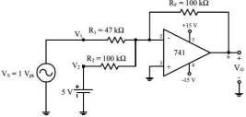

**Procedure:**

To demonstrate the use of an operational amplifier as a summing amplifier, connect the circuit of Figure 1.

1. With VS adjusted to produce a 1 V peak sine wave at 1 kHz, observe the output voltage VO (and VS to note the phase relationship) on an oscilloscope set to dc input coupling.
2. Sketch the output voltage waveform. Be sure to note the dc level in the output.
3. Interchange the 5 V dc power supply and the 1 V peak signal generator.
4. Repeat procedure step 2 and observe the change in output waveform.

**Part B**

**Difference Amplifier:**

A difference amplifier is a special purpose amplifier designed to measure differential signals, otherwise known as a subtractor. A key feature of a difference amplifier is its ability to remove unwanted common mode signals, known as common mode rejection (CMR). Unlike most types of amplifiers, difference amplifiers are typically able to measure voltages beyond the supply rails, and are used in applications where large dc or ac common-mode voltages are present. They are ideal for current and voltage monitoring. Analog Devices offers a range of difference amplifiers, optimized for low distortion, low power, or high voltage performance.

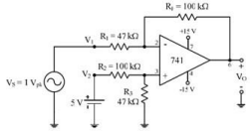



This equation can be simplified by making **R3 = Rf = R1 = R2**, yielding a simple differential amplifier with unity gain:

**V0 = V2 - V1**

**Procedure:**

1. To investigate the use of an operational amplifier in a difference amplifier configuration, connect the circuit of Figure 2.
2. With VS adjusted to produce a 1 V peak sine wave at 1 kHz, observe the output voltage VO (and VS to note the phase relationship) on an oscilloscope set to dc input coupling.
3. Sketch the output voltage waveform. Be sure to note the dc level in the output. 4. Interchange the 5 V dc power supply and the 1 V peak signal generator.
4. Repeat procedure step 2 and observe the change in output waveform.

**OBSERVATIONS:**

**PART A:**

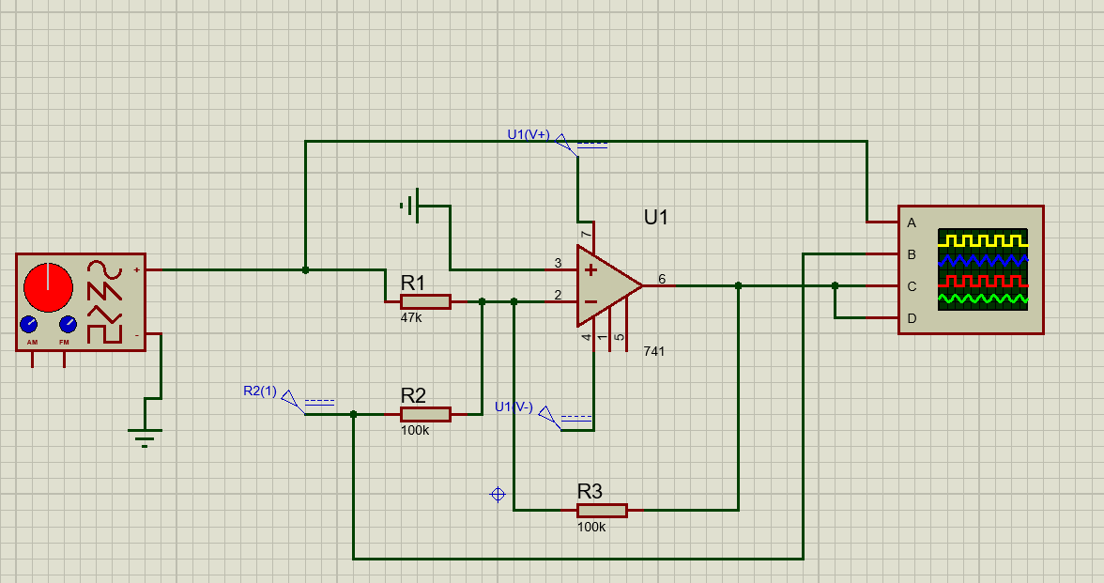

Inverting Summing Amplifier

**CALCULATIONS:**

$$V_{o}=-\left(\frac{R_{f}}{R_{1}}+\frac{R_{f}}{R_{2}}\right)$$

Putting Values

$$V_{o}=-\left(\frac{100K}{47K}×1+\frac{100K}{100K}×5\right)$$

$$V_{o}=-\left(2.127+5\right) V$$

$$V_{o}=-2.127-5 V$$

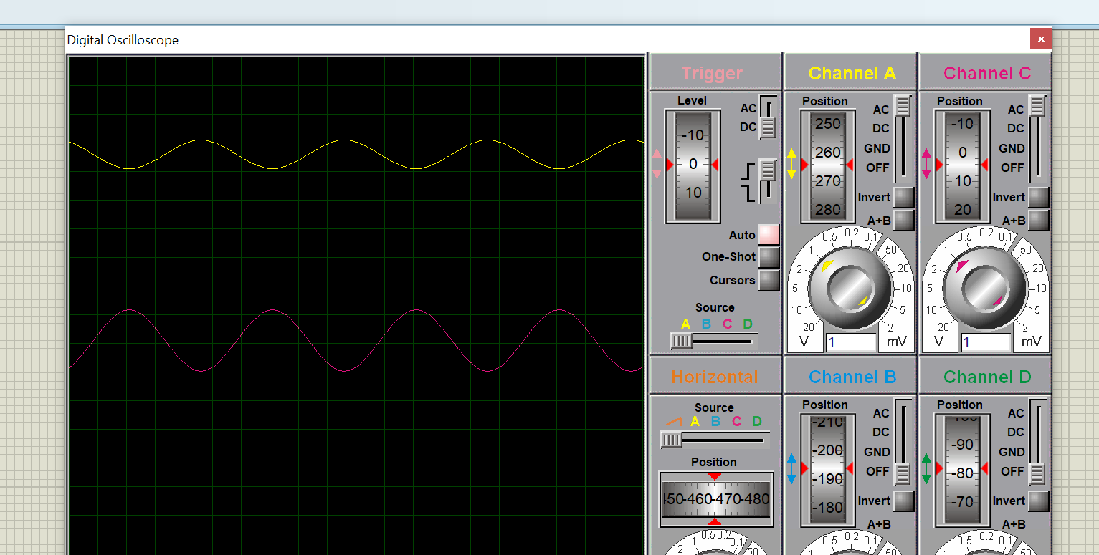

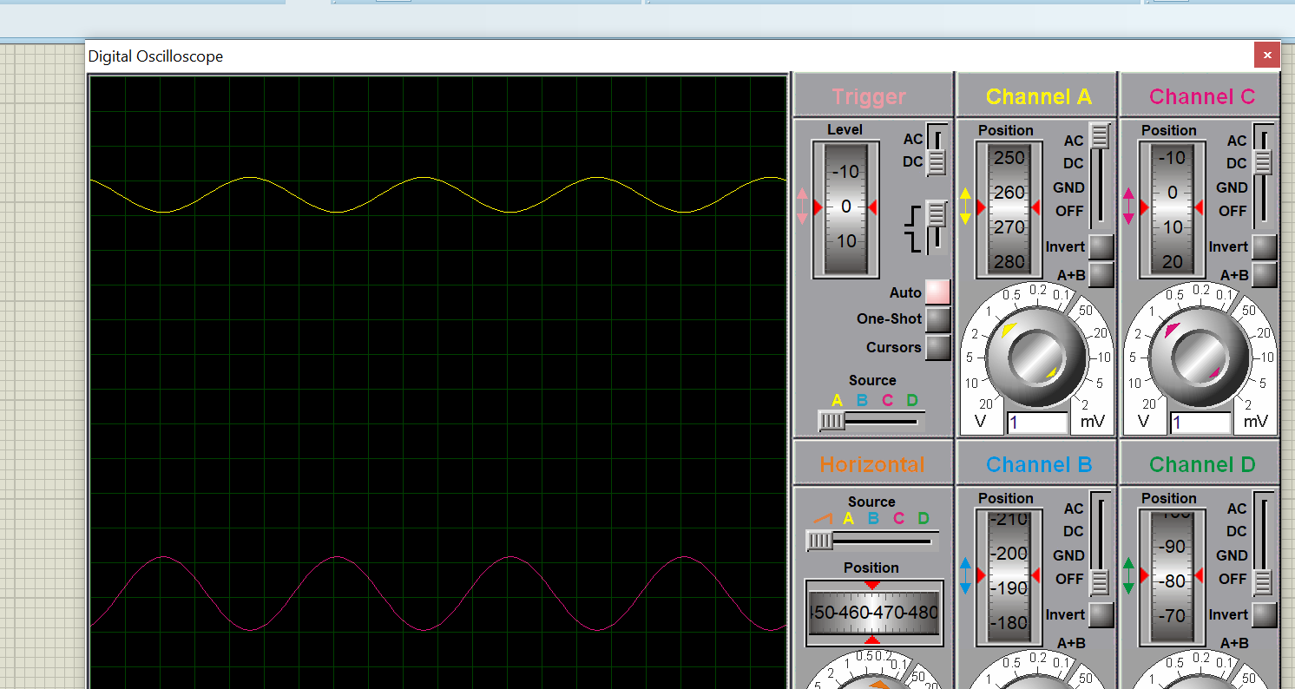

**PART B:**

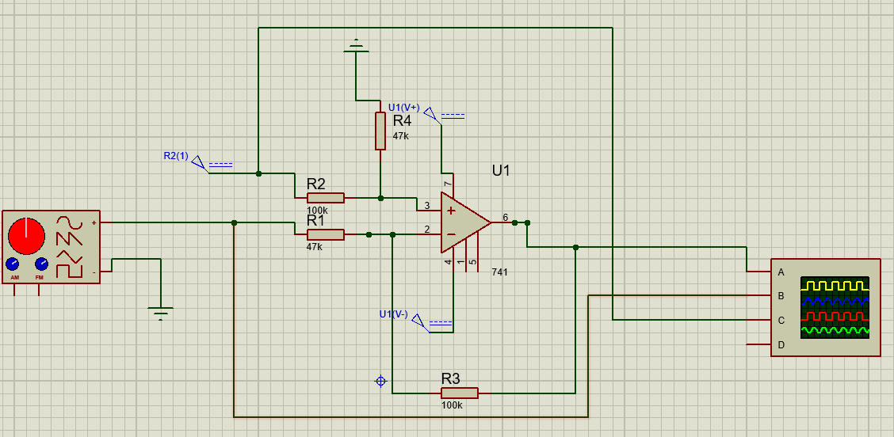

Difference Amplifier

**CALCULATIONS:**

$$V_{o}=\frac{R_{f}}{R_{a}}\left(V_{b}-V_{b}\right)$$

Putting Values

$$V_{o}=\frac{100K}{47K}\left(5-1\right)$$

$$V_{o}=2.127\left(5-1\right) V$$

$$V_{o}=10.638-2.127 V$$

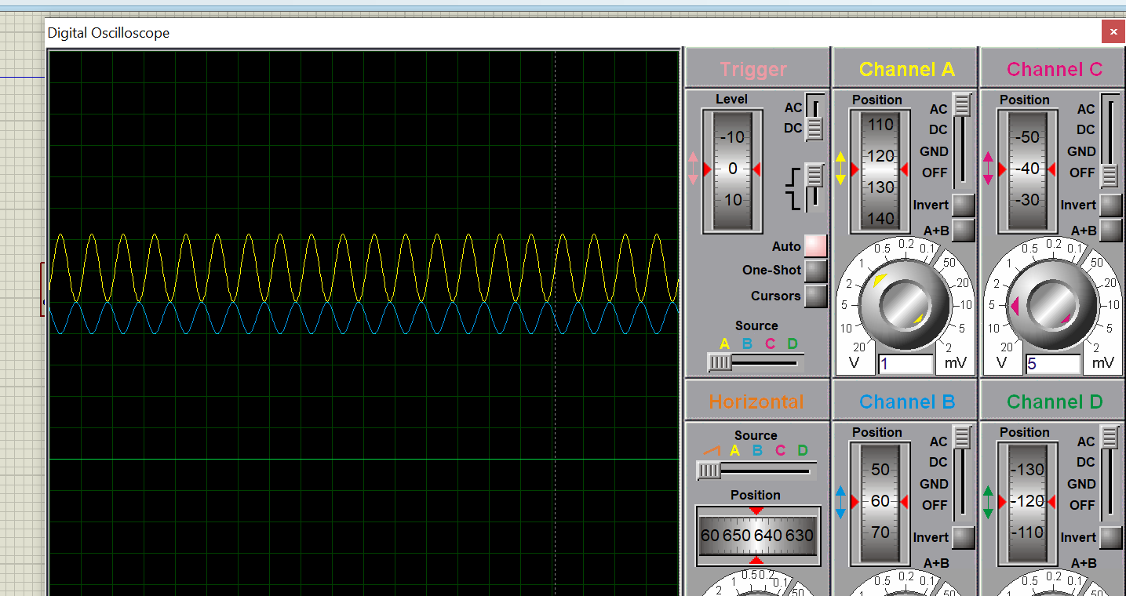

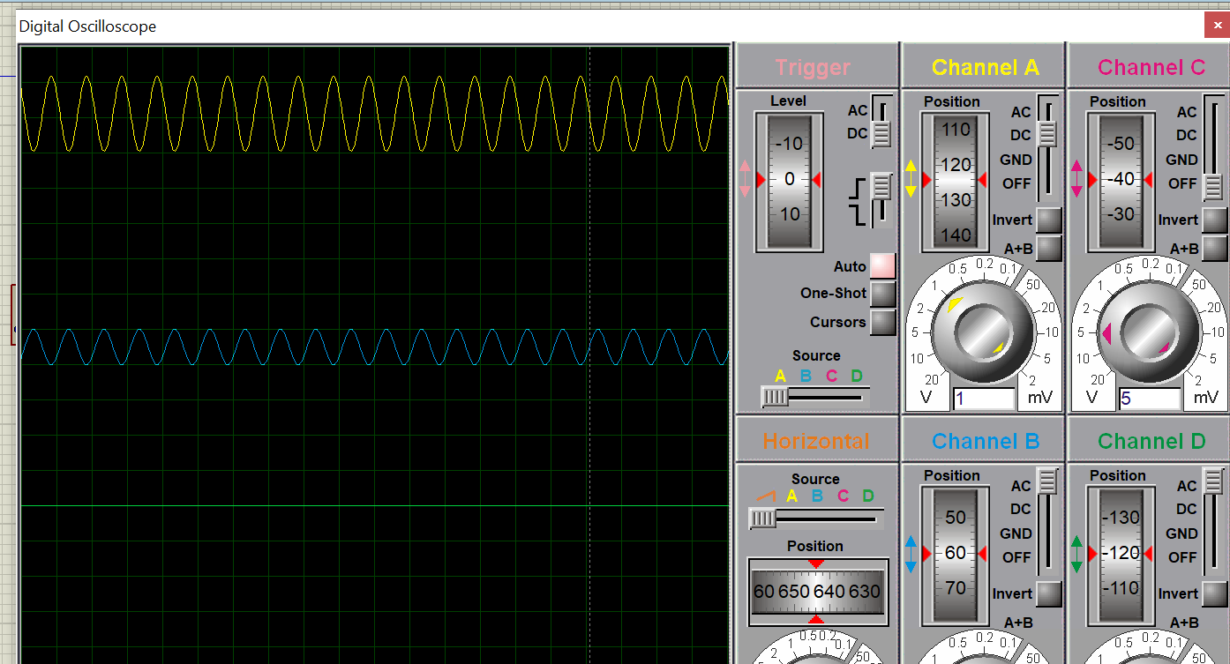

**CONCLUSION:**

We conclude the following results from this experiment:

* Operational Amplifier can be used for performing different mathematical operations like addition, subtraction etc.
* In Oscilloscope, we cannot add AC with DC signal. In order to see their sum, the oscilloscope shift the AC wave/signal in upward/ downward direction.